**Class #2**

Jenkins Plugin’s

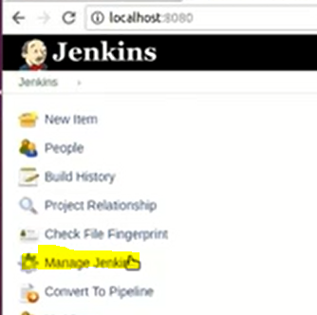

All the Installed plugins are availabl in Manage Jenkins >Manage Plugin’s

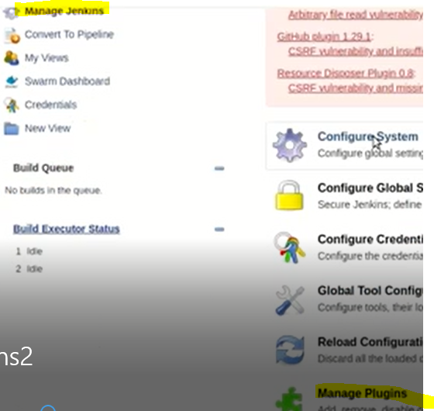

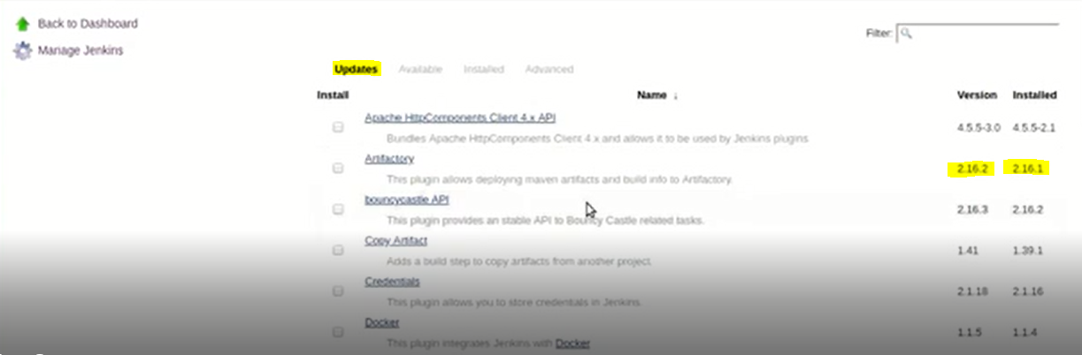

We can updated the version of installed plugin if new version is available its show in above fig

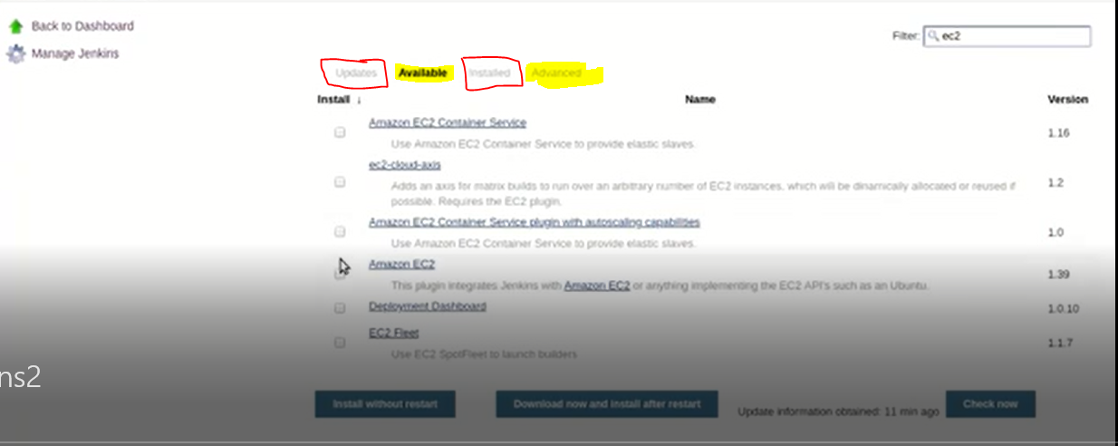

Here we have Installed plugin’s, Available plugin’s.

We can Install the required plugin which we want, above we have type Ec2 so we can Install Ec2 plugin

Plugin extension is **.hpi**

**For some Tools/Process plugins are not available for that we can develop our own plugin and we can upload that plugin to Jenkins**

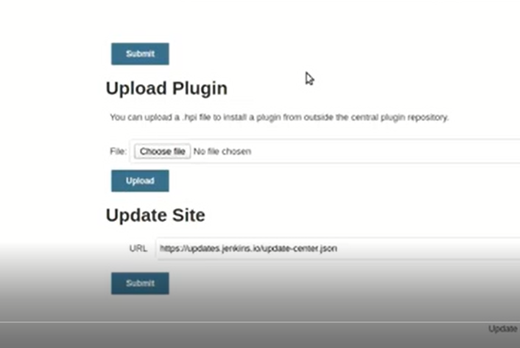

In Manage Plugin Advance Tab upload option will available.

**Jenkins Configuration settings**

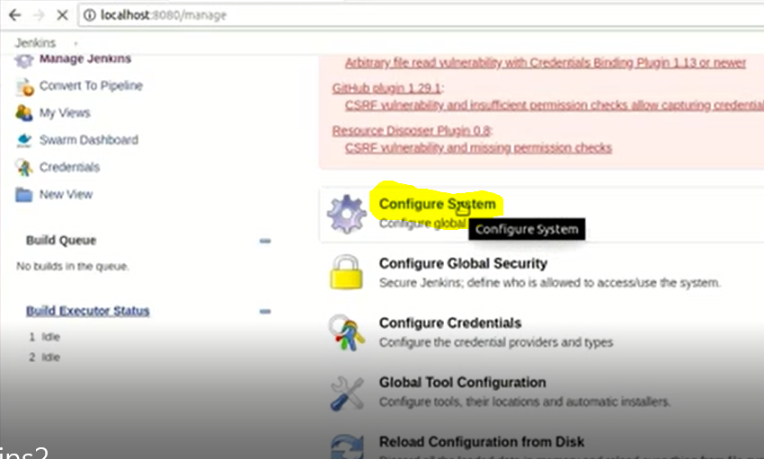

**Configure system Dashboard**

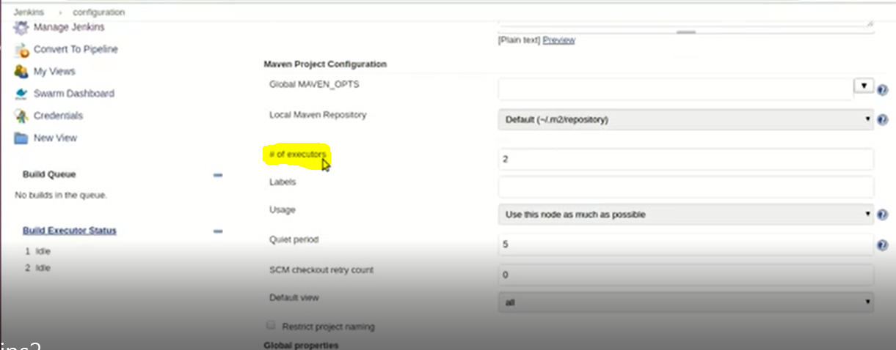

**It will change by installing more plugin’s , I mean we can see multiple options**

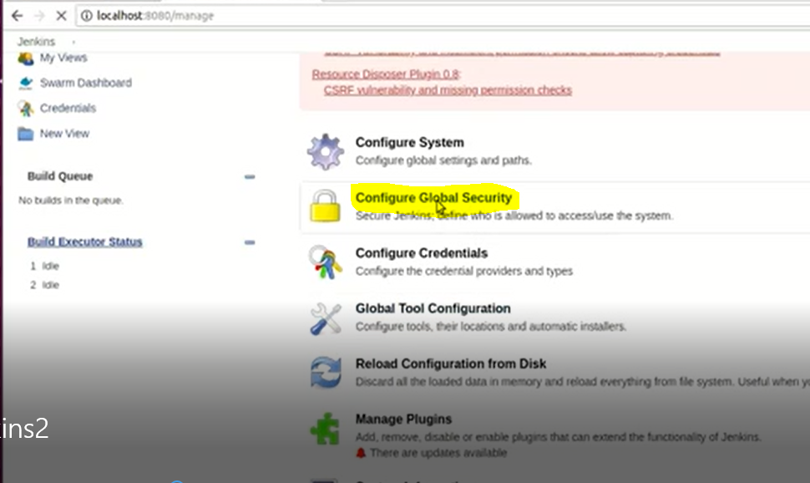

**Configure Global Security**

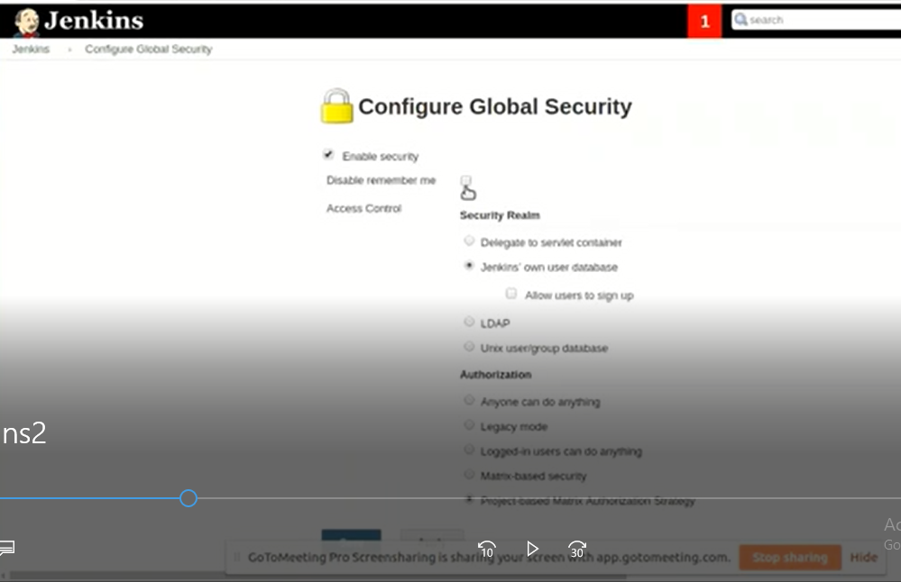

Here we will provide security, here we can create Groups/User and provide required permissions

We can create one user and we are able to restrict permission levels

Like Read, write, Execute …..

Here we have some Plugins to create users/Groups and set permissions like below

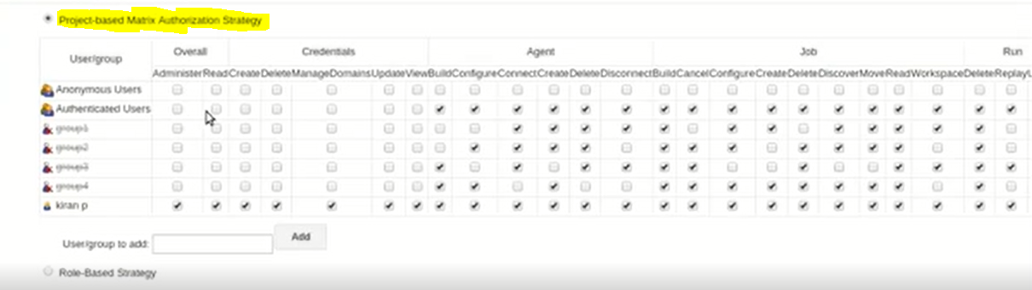

**We can see all the plugins installed in Jenkins from Manage Jenkins>Global Tool Configuration**

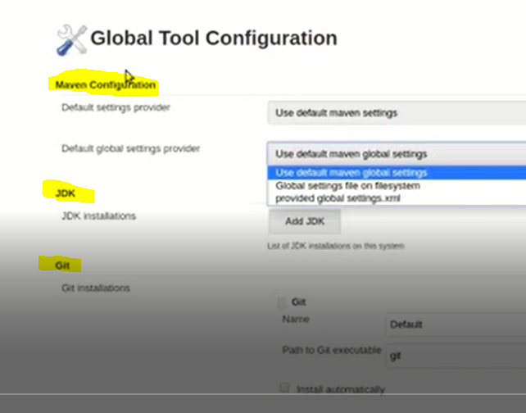

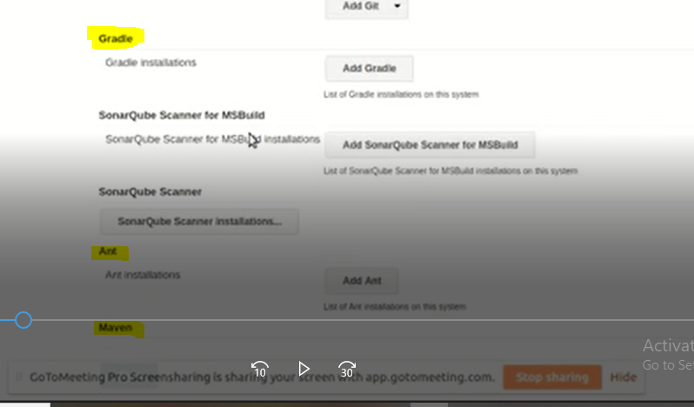

**We can Install required Plugin from Jenkins console from Global Tool configuration like above**

**We can Install Multiple versions of same plugin if required in our project like below**

**Here we are installing Maven versions**

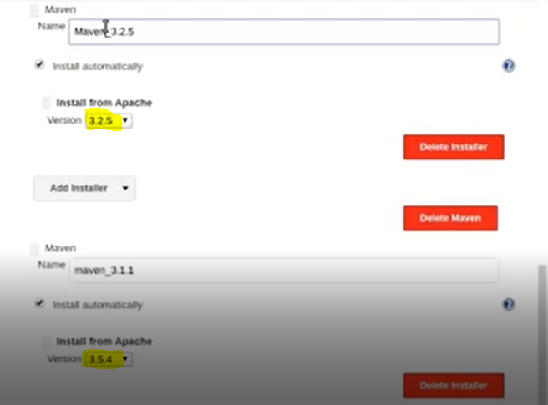

**Once we install any plugin we must Restart plugin to reflect it.**

**We can Restart Jenkins by following below process**

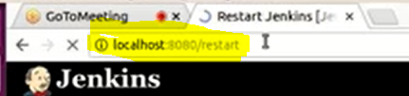

**localhost:8080/restart**

**Plugin Uninstalling process**

**Go to Installed plugin and click on Uninstall if you want to uninstall**

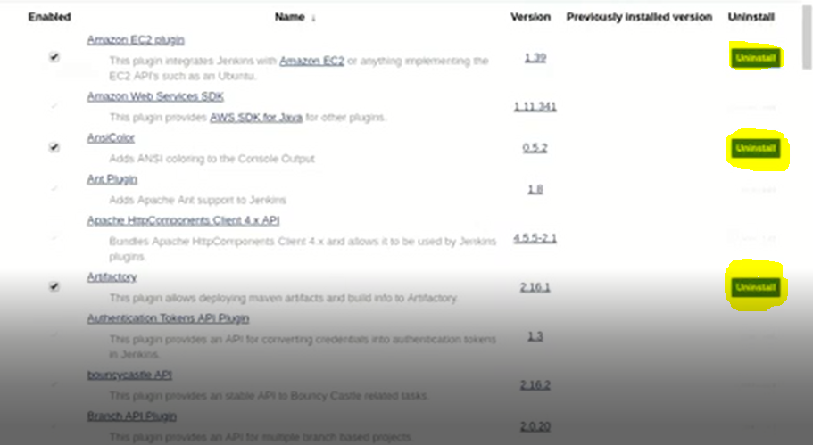

**Jenkins have one configuration file which includes total Jenkins configuration i,e; Jenkins Home directory(/var/lib/Jenkins)**

**Once we installed Jenkins in our Machine total config will save in this file**

**We have to take this file backup in very one hour or as per our plan/requirement by developed one script**

**So that if anything happened to our current existing Jenkins server, we will install new Jenkins server and we will replace this backup file so that we will get total Jenkins Server with old configuration**

**This file location is exist in GUI is >Manage Jenkins>configure system>Home directory**

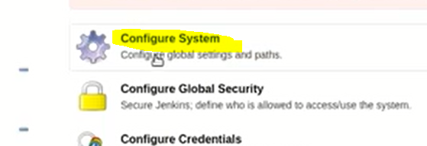

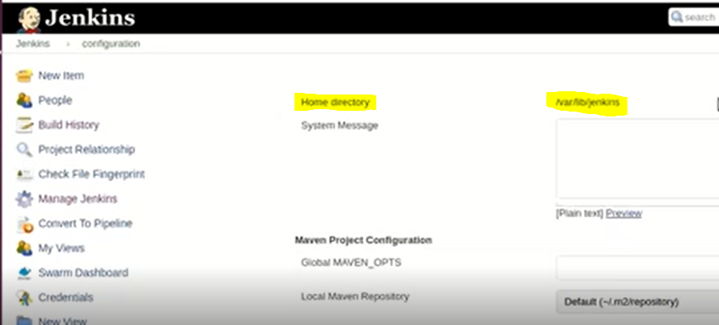

**About Jenkins Logs**



**It will capture all the operations done by Jenkins Server**

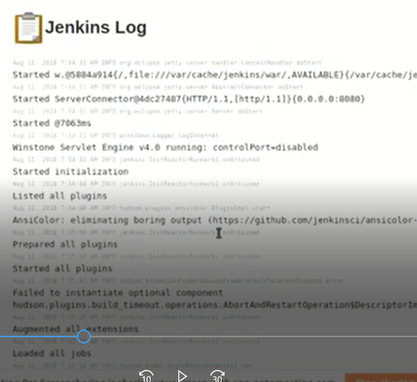

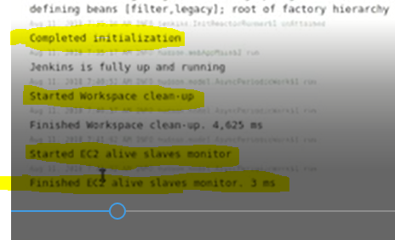

**New Project Creation**

**Step1: Below we have selected Freestyle Project and we have provided project name as Test_pro**

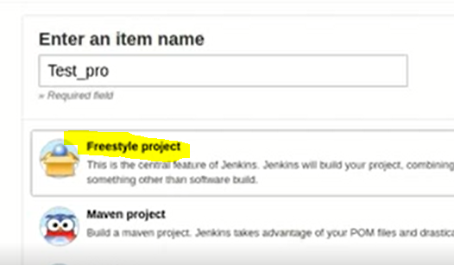

**Step 2: Here we have to provide repository details like below, and we have to provide Repository Credentials then only we can clone the code**

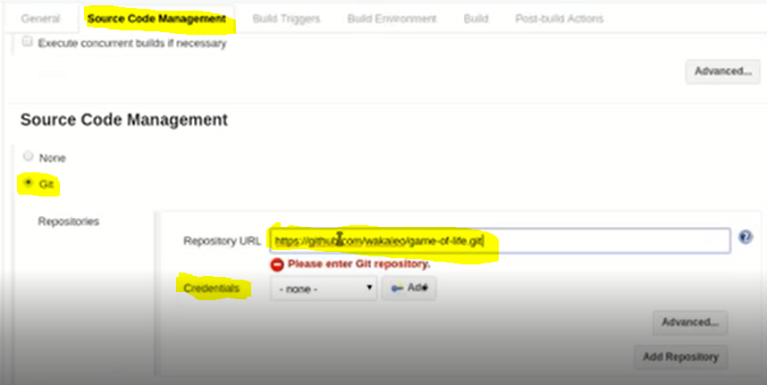

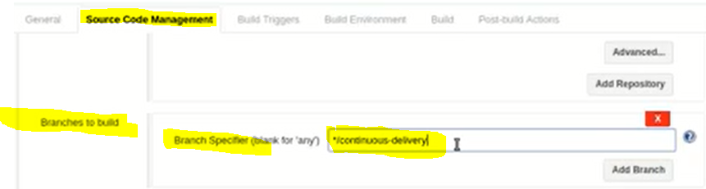

**Here we have provided the Branch details of Repository , so that code will pick from that branch, In Git Repository we can create Multiple branches to commit the code.**

**So we have to provide the Branch details so that it will clone the code from that branch**

**Example of Git Branches**

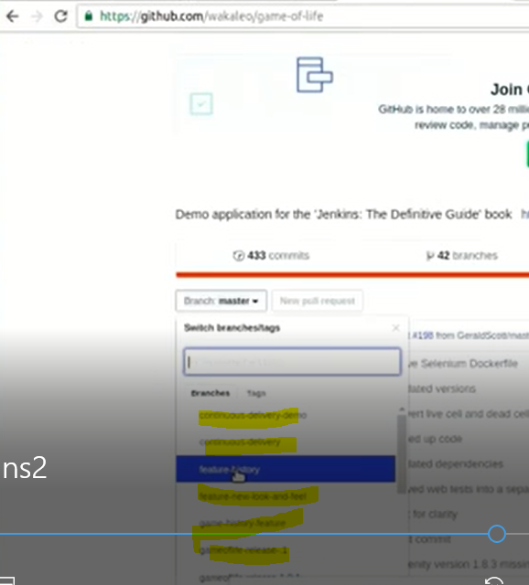

**Above we have configure one that which will fetch code from Git Repository.**

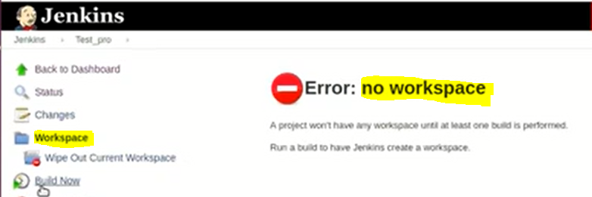

**Till now we did not Fetch any code that is the reason it showing No workspace**

**Now we are going to Run the configured Job to clone the data from Git.**

**By clicking Build now that job will execute**

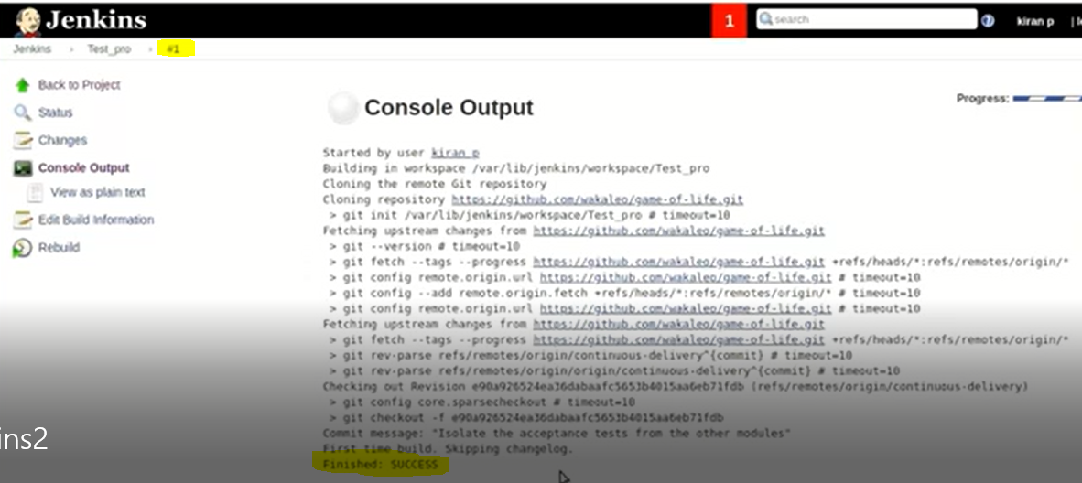

**Executed successfully and its 1st build(version)**

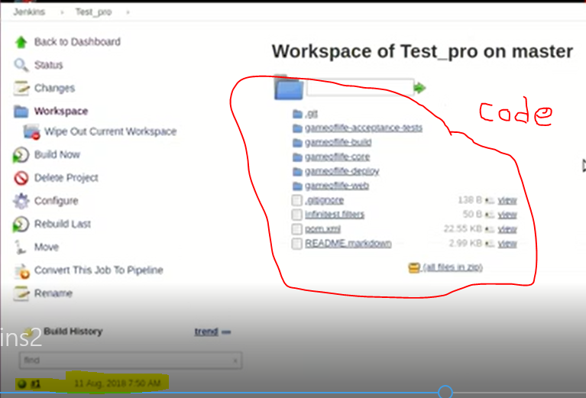

**If we want to configure New Job form Existing Project , click on Configure then it will move to configuration console**

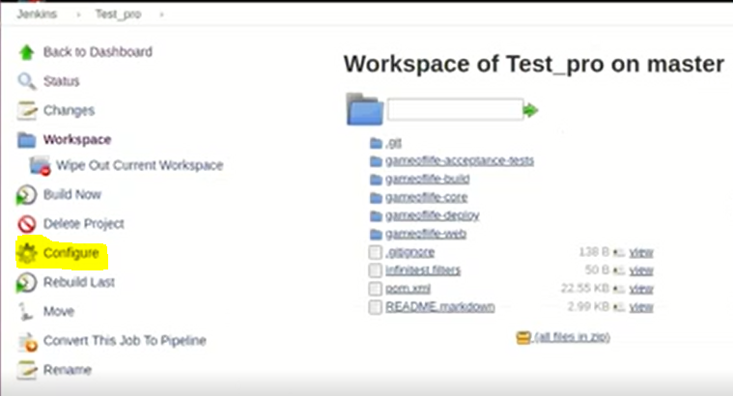

**Now we are planning to create Build Job**

**Sequence order ,,,,,,Complile>Test(Unit Test), Build>Deployment(Installation of App)**

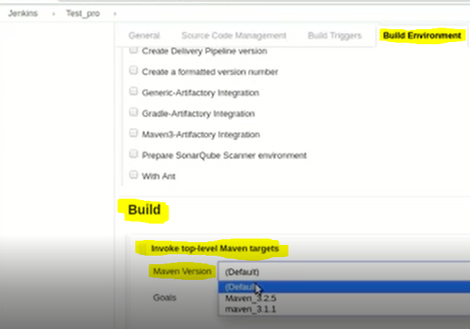

As we discussed above that we can Install multiple versions of Tools(Maven,Git…..etc) in Jenkins

Based on our requirement we will use those

Above we have selected Maven build and selecting required version

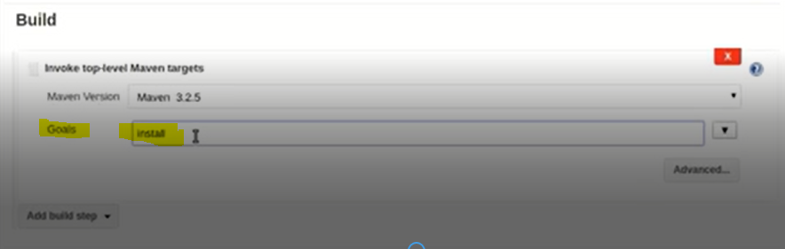

We have to provide Goal details in the process of Creation Build the following steps by process will execute (Compile, Test, Build and Deploy (Install)

If we see in above Goal configuration we have provided Install , so here we have created Job for Install the Application(Deployment)

Here in build process if we provide Goal is “Install” then in this case the first remaining 3 process I,e; (Compile , Test and Build ) will execute automatically. This is the behavior of Maven Build process.

While Building/Deploying the Application Maven needs some dependencies and Plugins to complete the Job

Dependencies (like some Java class) and those Dependencies and Plugins will download at first time only

In java Project/Application we will have **pom.xml file it includes the details of some external resources which will use to connect to deploy the code.**

**If we don’t install any plugin then only Freestyle Project is available**

**Generally the below 3 highlighted models projects are important and most of the projects will Run by using those**

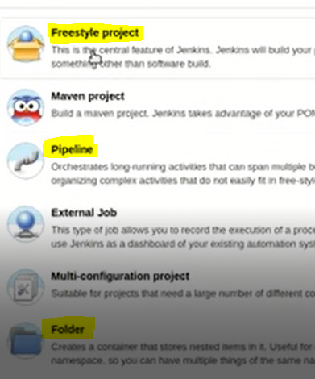

**For example we have 10 projects and each project have 20 jobs then total jobs is 200 and those all will available in Jenkins dashboard like below.**

**If we want to Run and job we have search for that particular job and have to Run, so here it will take some time because we have to filter it from that 200 jobs.**

**In this case here we will choose Folder Model for our Project , so we can create separately by following below process**

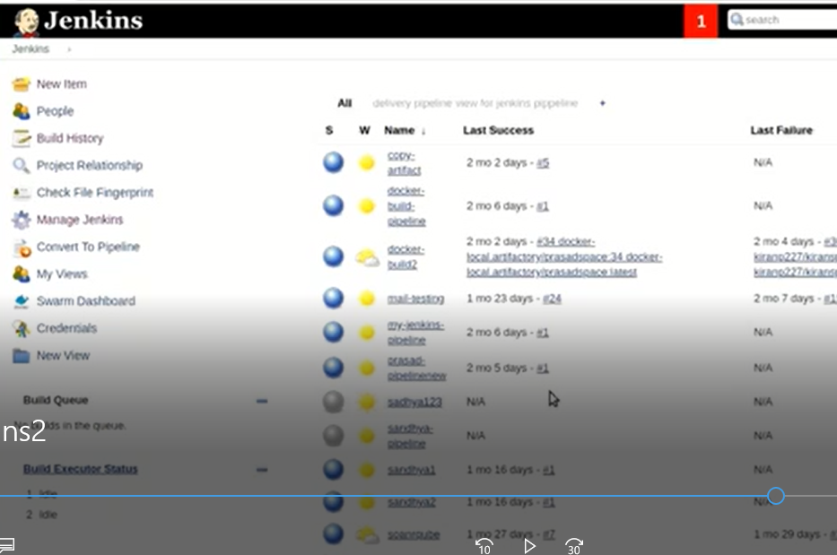

**Folder Model project**

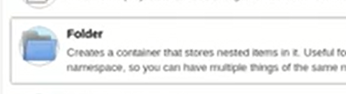

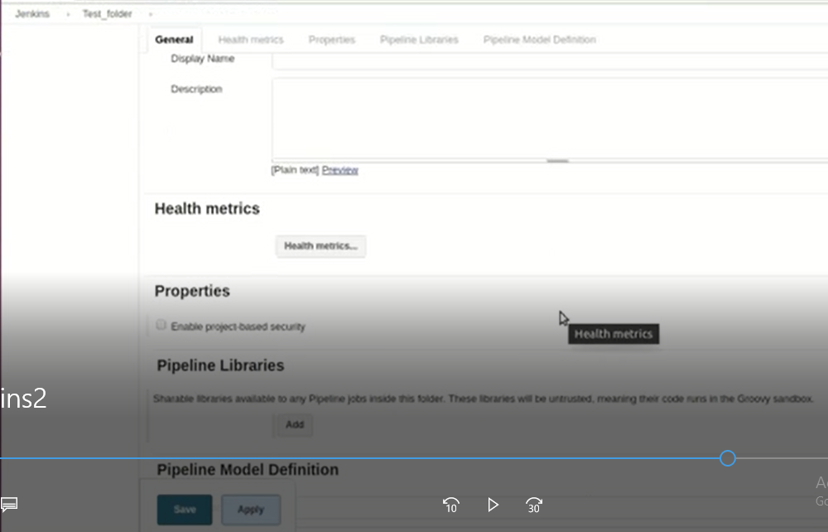

**By following above process we have created one folder with Name Test_folder, Now we can create N-number of jobs under it by clicking Create new Job**

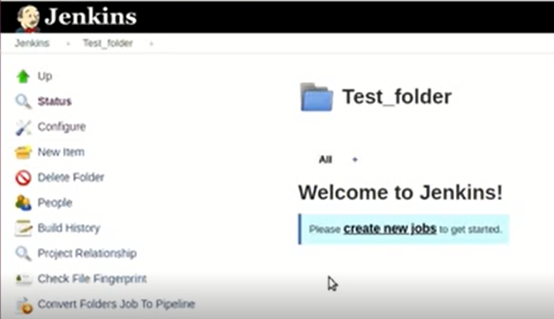

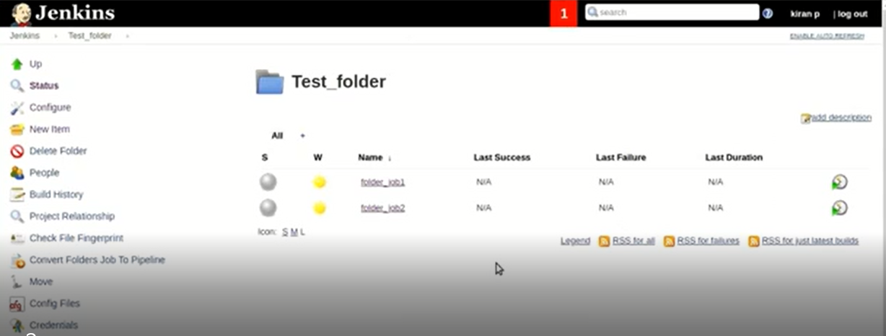

**Like below we can create folders under folders we can create N number of jobs**



**Email Notification in Jenkins**

**In Jenkins we can configure post build notifications**

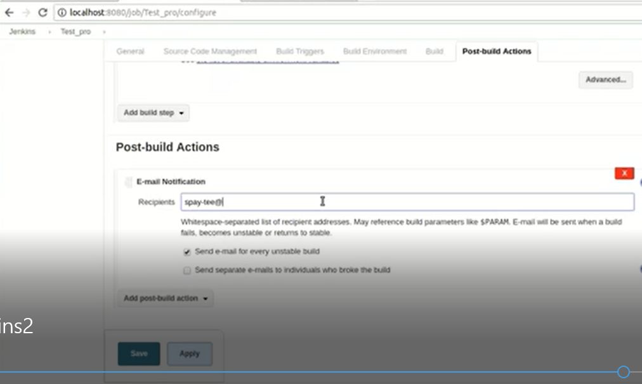

**We have selected E-mail Notifications action and here we have to provide Recipetions (Mail id/ Group DL)**

**In Jenkins we have Pipeline Module , its nothing but we are run multiple jobs in Sequence order by following below process**

**We have job one once it completed some other jobs have to execute continuously**

**For this requirement we have to go to configuration from Job one and have to move to post build action>then Build other projects like below**

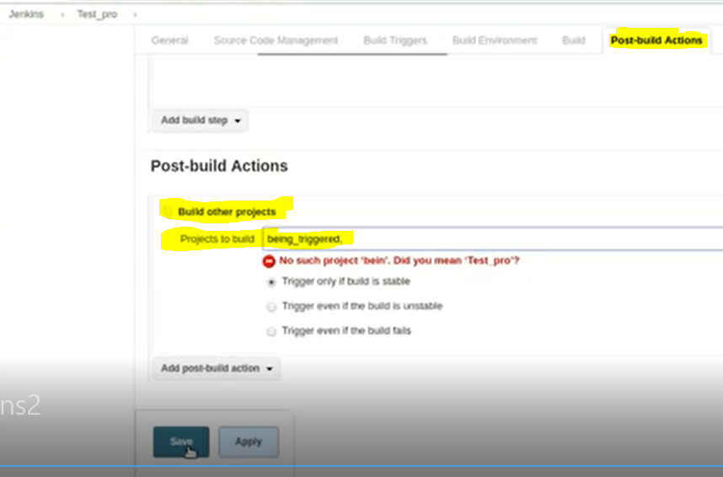

**So we can configure pipeline in Jenkins.**

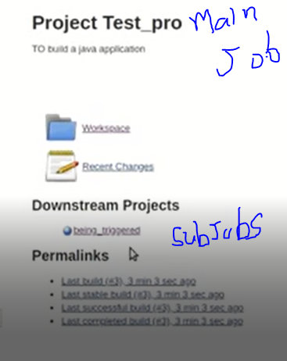

**In General process once Build is created that Build will store in Nexus/Jfrog Artifactory repository before deployment**